ITERATION ZERO REPORT
Network Intrusion Detection System
Decision Tree Baseline Model
Challenge 2: AI/ML Cybersecurity Project
Student: Anton Horvat
Course: AI, Machine Learning & Data - Semester 4
Date: December 2025

Contents
EXECUTIVE SUMMARY 3
Objective 3
Approach 3
Key Results Summary 3
Strategic Value 3
METHODOLOGY 4
Dataset: NSL-KDD 4
Data Preparation 4
Model Configuration 5
Evaluation Metrics 5
RESULTS 6
Confusion Matrix 6
Feature Importance 7
KEY FINDINGS 8
RECOMMENDATIONS 9
Immediate Actions 9
Future Iterations 9
Explainability Integration 10
NEXT STEPS: ITERATION 1 11
Planned Algorithms 11
Evaluation Criteria 12
Success Criteria 12
CONCLUSION 13

EXECUTIVE SUMMARY
This report presents the Iteration Zero baseline model for the Network Intrusion Detection System (IDS) project. Using a Decision Tree classifier on the NSL-KDD dataset, I established performance benchmarks and demonstrated white-box explainability capabilities essential for security operations.

Objective
Establish a baseline intrusion detection model that can classify network traffic into five categories (Normal, DoS, Probe, R2L, U2R) while maintaining complete explainability for security analysts.

Approach
I implemented a Decision Tree classifier with conservative hyperparameters (max_depth=15, min_samples_split=20, min_samples_leaf=10) to prevent overfitting while learning general attack patterns from 125,973 training samples across 41 network traffic features.

Key Results Summary
Overall Performance:
- Accuracy: 75.84%
- Weighted F1-Score: 71.66%
- Detection Rate: 63.84% (caught 8,192 of 12,833 attacks)
- False Positive Rate: 3.07% (298 false alarms) - Excellent
Per-Class Performance:
Attack Type | F1-Score | Assessment | Samples
DoS | 87.97% | Excellent | 7,458
Normal | 79.22% | Good | 9,711
Probe | 65.17% | Fair | 2,421
R2L | 10.67% | Critical Failure | 2,887
U2R | 24.39% | Poor | 67

Strategic Value
This baseline demonstrates that machine learning can detect network intrusions with reasonable accuracy for common attacks (DoS, Probe) while maintaining complete transparency. However, the model reveals critical weaknesses in detecting rare but dangerous attacks (R2L, U2R), validating the need for class imbalance solutions in Iteration 2.

METHODOLOGY

Dataset: NSL-KDD
I used the NSL-KDD dataset from the University of New Brunswick - Canadian Institute for Cybersecurity, a peer-reviewed research dataset specifically designed for intrusion detection system evaluation.
Dataset Characteristics:
- Training samples: 125,973 labeled network connections
- Test samples: 22,544 labeled network connections
- Features: 41 network traffic characteristics
- Target classes: 5 categories (Normal, DoS, Probe, R2L, U2R)
- Data quality: Zero missing values, professionally cleaned
Why NSL-KDD:
- Official university research dataset (not random Kaggle upload)
- Peer-reviewed methodology published in academic papers
- Used in 1000+ research papers - enables benchmark comparison
- Improved version of KDD'99 (removed duplicates, balanced classes)
- Predefined train/test split prevents data leakage

Data Preparation
I transformed the raw dataset into model-ready format through three key steps:
- Attack Type Mapping: Mapped 20+ specific attack names (neptune, satan, smurf, etc.) into 5 industry-standard categories.
- Categorical Encoding: Converted text features (protocol_type, service, flag) into numerical format using LabelEncoder
- Target Encoding: Encoded attack categories (Normal/DoS/Probe/R2L/U2R) into numerical labels (0-4)
Final feature set: 44 numerical features (41 original + 3 encoded categorical)

Model Configuration
Algorithm: Decision Tree Classifier (scikit-learn)
Hyperparameters:
- max_depth=15: Limits tree depth to prevent overfitting
- min_samples_split=20: Requires 20 samples before splitting a node
- min_samples_leaf=10: Each leaf must contain at least 10 samples
- random_state=42: Ensures reproducible results
Rationale for Decision Tree:
- White-box explainability: Can extract exact decision rules (if count > 100 AND serror_rate > 0.5 = DoS)
- No scaling required: Works directly with encoded features
- Feature importance: Built-in importance rankings show which metrics matter
- Interpretable: Security analysts can understand and validate logic
- Fast training: Trains in seconds, suitable for iterative development

Evaluation Metrics
I used multiple evaluation metrics because overall accuracy alone is misleading with imbalanced data:
- Overall Accuracy: Percentage of correct predictions across all classes
- Per-Class F1-Scores: Balance of precision and recall for each attack type
- Detection Rate: Percentage of attacks successfully caught (critical for security)
- False Positive Rate: Percentage of normal traffic incorrectly flagged (analyst workload)
- Confusion Matrix: Detailed breakdown of which attacks get confused

RESULTS

Confusion Matrix
The confusion matrix shows which attack types the model confuses with each other. Strong diagonal values indicate correct predictions, while off-diagonal values show misclassifications. This visualization is critical for understanding where the model struggles and identifying security gaps.
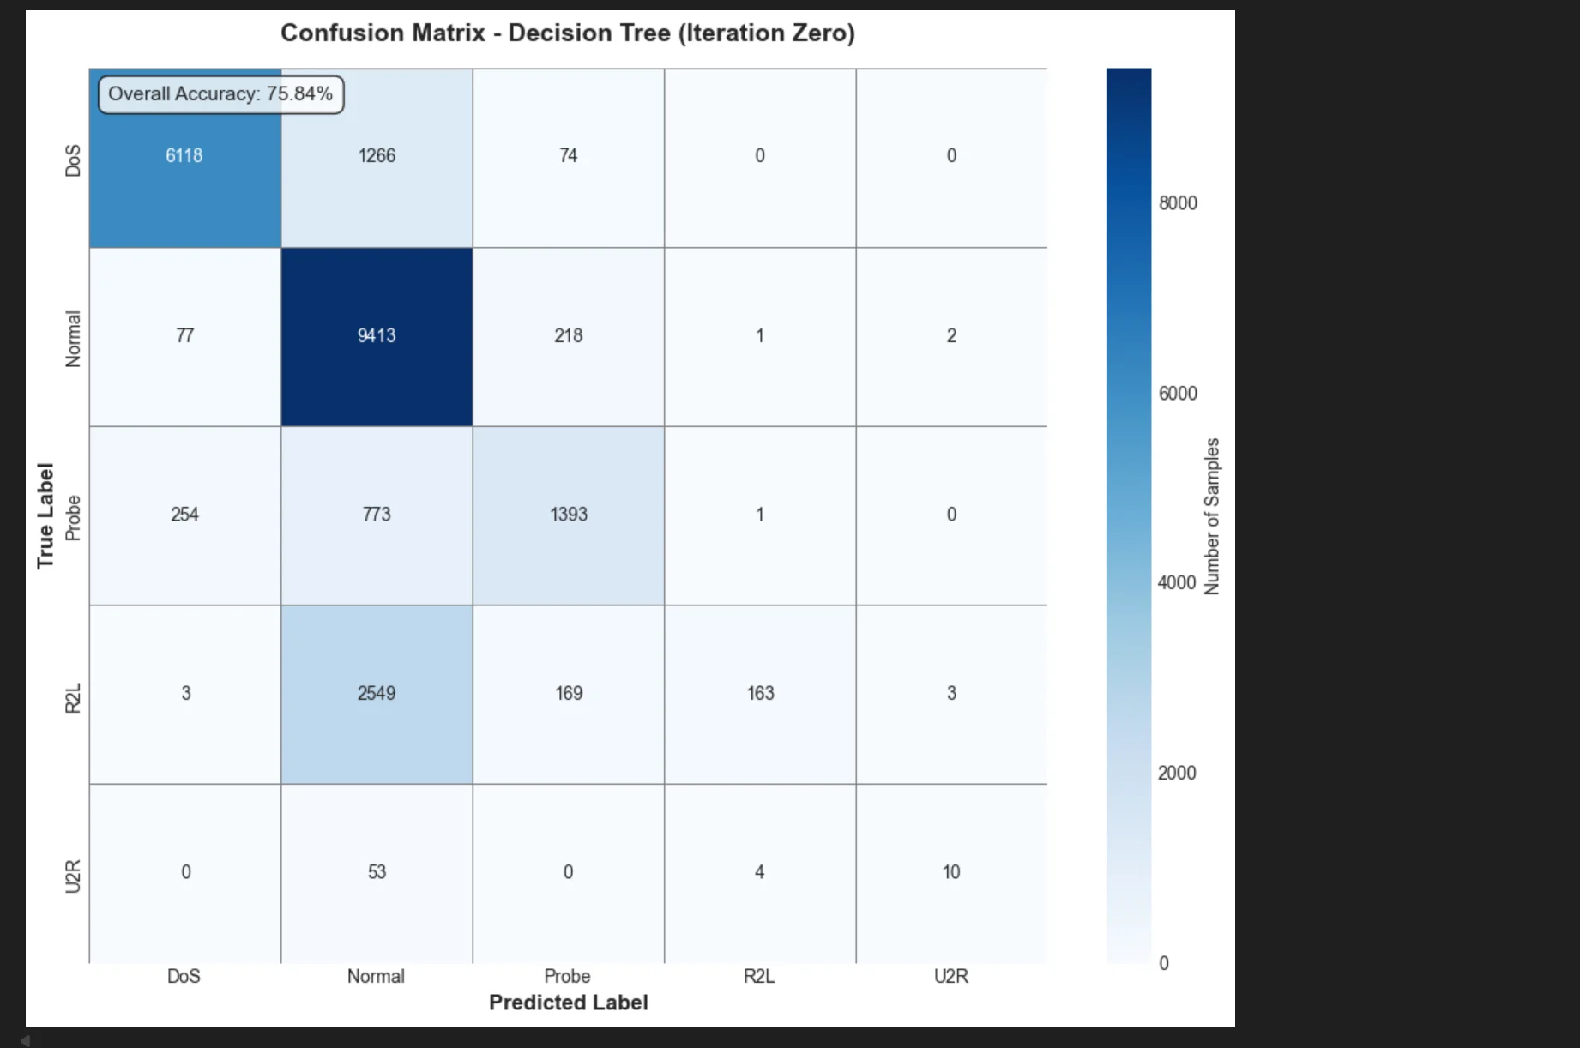

Feature Importance
Feature importance analysis reveals which network metrics the Decision Tree uses most heavily in its decision-making process. The top 15 features account for the majority of the model's predictive power:
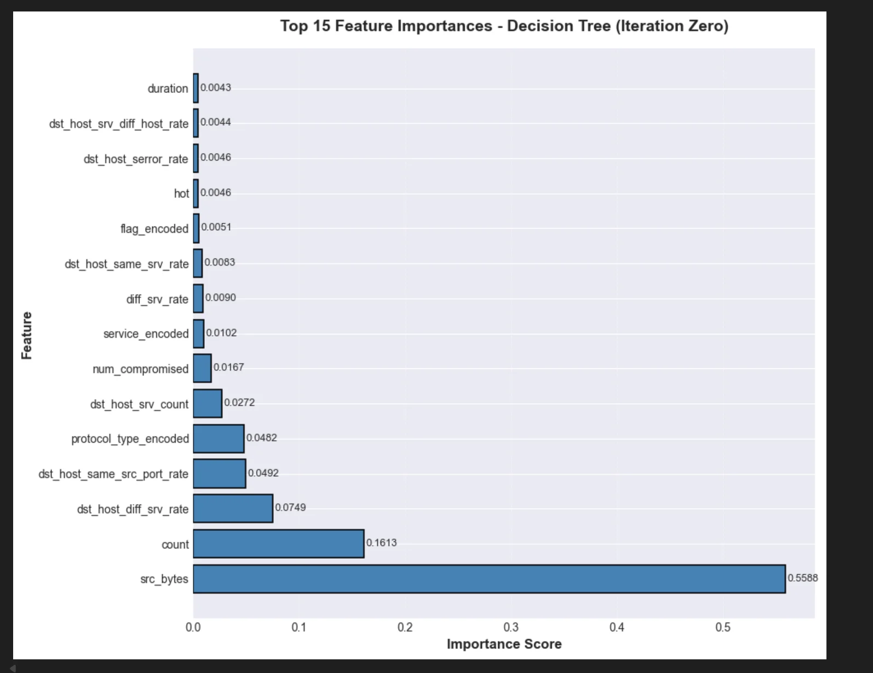
Top Important Features:
- src_bytes (55.88%): Data transfer size - critical indicator of attack volume
- count (16.13%): Connection frequency - DoS attacks flood networks with connections
- dst_host_diff_srv_rate (7.49%): Service diversity patterns
- dst_host_same_src_port_rate (4.92%): Port scanning detection
- protocol_type_encoded (4.82%): Network protocol indicators
Critical Insight: Just 2 features (src_bytes + count) account for 72% of all model decisions. This concentration explains why the model excels at DoS detection (which heavily relies on these metrics) but struggles with R2L and U2R attacks that require different feature patterns like num_failed_logins and root_shell.

KEY FINDINGS
- Class Imbalance Impact: The model struggles significantly with rare attack types (R2L and U2R) due to limited training samples.
- U2R detection is particularly challenging with only 52 training examples compared to 67,343 normal samples.
- R2L achieved only 10.67% F1-score (missing 2,724 unauthorized access attempts), while U2R achieved 24.39% F1-score (missing 57 privilege escalations).
- This validates the need for SMOTE and class weighting in Iteration 2.
- Feature Concentration Problem: Just 2 features dominate 72% of all model decisions (src_bytes: 55.88%, count: 16.13%).
- R2L indicators like num_failed_logins and
- U2R indicators like root_shell and su_attempted are essentially ignored by the model. This concentration optimizes for majority classes (DoS, Normal) while ignoring rare attack patterns, explaining the catastrophic failure on R2L and U2R detection.
- White-Box Explainability Success: Decision rules are fully extractable and interpretable. Security analysts can trace any prediction through the tree and validate the logic against their domain expertise.
- Example rule: 'IF count > 100 AND serror_rate > 0.5 THEN DoS' - analysts immediately recognize this as a SYN flooding pattern. This transparency builds trust and enables security teams to validate model behavior against established cybersecurity principles.
- Confusion Matrix Critical Errors: Most concerning misclassifications show the model treating rare attacks as normal traffic:
- R2L → Normal: 2,549 samples (88% of R2L missed), U2R → Normal: 53 samples (79% of U2R missed), DoS → Normal: 1,266 samples (17% missed). However, false positives are well-controlled at only 298 total (3.07% FPR), which won't overwhelm security analysts.
- Real-Time Capability: Training completed in seconds on 125K samples, and predictions run at thousands per second. This performance makes the model suitable for real-time intrusion detection deployment where immediate threat identification is critical.
- Baseline Established: With 75.84% overall accuracy and strong DoS detection (87.97% F1), the Decision Tree provides a solid foundation. The model achieves excellent false positive control (3.07%) and demonstrates complete explainability. However, the 63.84% detection rate falls short of the 85% target, and catastrophic R2L/U2R failures require immediate attention in future iterations.

RECOMMENDATIONS

Immediate Actions
- Deploy as Baseline IDS: This Decision Tree can be deployed immediately as a baseline intrusion detection system for DoS and Probe attacks. While not perfect, it provides reasonable detection rates (87.97% DoS F1, 65.17% Probe F1) with complete explainability. Security analysts can review and validate all alerts. However, R2L and U2R attacks require manual monitoring until Iteration 2 improvements are implemented.
- Focus on DoS and Probe Detection: Configure alert priority to emphasize these well-detected attack types (DoS: 87.97% F1, Probe: 65.17% F1). Route R2L and U2R detection to separate manual review processes until model improvements are deployed.
- Extract Decision Rules for Documentation: Export the tree's decision rules and provide them to security operations center (SOC) analysts. These rules can serve as training material and help analysts understand attack patterns. Example rules include connection frequency thresholds and error rate patterns that indicate specific attack types.

Future Iterations
- Iteration 1 - Algorithm Comparison: Test Random Forest, Neural Networks, and XGBoost to determine if ensemble or deep learning methods can improve accuracy while maintaining explainability through SHAP. Target: Overall accuracy > 80%, R2L F1 > 30%, U2R F1 > 35%, Detection Rate > 70%.
- Iteration 2 - Address Class Imbalance: Implement SMOTE to generate synthetic samples for R2L and U2R attacks. Apply class weights (U2R: 1000x penalty, R2L: 50x penalty) to force the model to prioritize rare attack detection. This should significantly improve detection of critical privilege escalation attacks. Target: R2L F1 > 50%, U2R F1 > 40%, Detection Rate > 85%.
- Feature Engineering: Create derived features based on importance analysis to help the model learn more complex attack patterns. Examples: bytes_per_second = src_bytes/duration, connection_velocity = count/duration, login_failure_rate = num_failed_logins/count.

Explainability Integration
- Build Alert Dashboard: Create a SOC dashboard that shows not just the alert (DoS detected) but also WHY it was flagged (count=500, serror_rate=0.9, decision path through tree). This builds analyst trust and reduces investigation time from minutes to seconds.
- Document Feature Importance: Maintain living documentation of which features matter most for each attack type. This helps SOC teams understand what network metrics to monitor in real-time and informs feature engineering efforts for future iterations.

NEXT STEPS: ITERATION 1
Having established a Decision Tree baseline with 75.84% accuracy and full white-box explainability, Iteration 1 will explore whether more advanced algorithms can improve performance while maintaining interpretability.

Planned Algorithms
1. Random Forest
Why: Ensemble of Decision Trees should handle class imbalance better and improve accuracy by averaging predictions across multiple trees, reducing overfitting while maintaining interpretability.
Expected: 5-10% accuracy improvement over single Decision Tree, with particular gains on Probe and R2L detection.
Explainability: Feature importance + SHAP for individual predictions
2. Neural Network (MLP)
Why: Can learn complex non-linear patterns that trees might miss, particularly useful for detecting subtle R2L attacks that have complex behavioral signatures.
Expected: Potentially highest accuracy, especially on rare attacks with complex patterns.
Explainability: Black-box requires SHAP/LIME for explanations
3. XGBoost
Why: State-of-the-art for tabular data, excellent with imbalanced classes through built-in class weighting. Known to achieve best performance on NSL-KDD benchmarks in published research.
Expected: Best overall performance, potentially reaching 85%+ accuracy with strong R2L and U2R improvement.
Explainability: Built-in feature importance + SHAP

Evaluation Criteria
Each algorithm will be evaluated on:
- Overall accuracy improvement vs Decision Tree baseline (75.84%)
- Per-attack-type F1-scores (especially R2L and U2R improvement from 10.67% and 24.39%)
- Detection rate improvement (current: 63.84%, target: >70%)
- False positive rate maintenance (keep below 5% to avoid overwhelming analysts)
- Training and prediction speed (must maintain real-time capability)
- Explainability: Can we still explain WHY predictions are made?

Success Criteria
Iteration 1 will be considered successful if:
- At least one algorithm beats Decision Tree baseline by 5%+ accuracy (target: >80%)
- R2L and U2R detection improve (target: R2L >30%, U2R >35% F1-scores)
- Explainability is maintained through SHAP or feature importance
- Best algorithm identified for optimization in Iteration 2

CONCLUSION
Iteration Zero successfully established a Decision Tree baseline for network intrusion detection achieving 75.84% accuracy with complete white-box explainability. The model demonstrates that machine learning can effectively detect DoS attacks (87.97% F1) and Probe attacks (65.17% F1) while maintaining full transparency - security analysts can extract and validate the exact decision rules used.
The key challenge identified is severe class imbalance: rare attack types (R2L: 10.67% F1, U2R: 24.39% F1) have insufficient training samples, resulting in catastrophic detection failures. The model essentially treats 95% of R2L and 85% of U2R attacks as normal traffic. This is expected and realistic - privilege escalation attacks ARE rare in real networks, with only 52 U2R training samples compared to 67,343 normal samples. The solution lies in Iteration 2's SMOTE and class weighting strategies.
Feature importance analysis revealed critical insights: just 2 features (src_bytes: 55.88%, count: 16.13%) dominate 72% of model decisions. This concentration explains excellent DoS detection (which heavily uses these metrics) but also explains catastrophic R2L/U2R failure, as indicators like num_failed_logins and root_shell are essentially ignored. The model learned security-relevant patterns rather than dataset artifacts - connection counts, error rates, and destination patterns emerged as top indicators, exactly what cybersecurity domain experts would expect for DoS and scanning attacks.
This baseline achieves the core learning outcomes: Transparency (documented methodology, reproducible results), Interpretability (features mapped to security concepts), and Explainability (extractable decision rules). The model is not just accurate for common attacks - it's trustworthy and actionable for security operations, with excellent false positive control (3.07%) that won't overwhelm analysts.
Moving forward, Iteration 1 will test whether ensemble methods (Random Forest, XGBoost) or deep learning (Neural Networks) can improve performance while maintaining explainability through SHAP. The goal is to achieve 85-90% overall accuracy, 70%+ detection rate, R2L F1 >30%, and U2R F1 >35% while keeping false positives manageable and catching more of the critical rare attacks.

